Public Transport Journey Planner
Team Leader: SHNZEN001, Zenan Shang
Architect: HTHERI001, Erin Heath
Communicator: BRNBEN005, Ben Brent
Supervisor: Jan Buys
Tutor: Linamandla Pikisa
Date: 25 September 2022

Table of Contents
Abstract 2
Introduction 2
Requirements Captured 3
Design Overview 6
User Interface: 7
Search and Store 7
Database 7
Textfiles 7
Implementation 9
User Interface 9
Search Route 10
Program Validation and Verification 11
Samples of test results 13
Conclusion 14
User Manual 14

Abstract
The following report provides an in depth view of the public transport journal planner created that allows a user to find an appropriate route from their desired start to end destination at a time and day of their choice. This report covers the requirements of the project and a design overview of how the application works. It also describes how the application was implemented to meet the requirements and the tests and validation designed and run to ensure that the program functioned appropriately and efficiently. A user manual is also attached to describe how a user can use the interface to interact with the application for optimal use.

Introduction
The purpose of this application is to allow users to be able to find transportation via train routes to their desired destination from a given start point within Cape Town. Users will be able to use the web application to identify their starting point of the journey and their end point, as well as identifying their desired starting time and day which will return a list of train routes available. It is the aim of this application to allow ease of organization for the user’s journey that provides them with maps of the available routes and provide them with available options of trips that meets their specifications. The application will prioritize trip planning by shortest time of the trip, with minimal connecting modes of transport that is most appropriate for their arrival or departure times as well as minimum durations for the trip to ensure user satisfaction. The user will be able to sign-up and login to the web application, allowing for their previous searches to be saved and displayed when they next login
We approached this problem by doing a traditional analysis of the project’s aims and designed an evolutionary prototype accordingly. We then implemented the design and tested it to determine the usability and effectiveness of the application. We then repeated the process, improving and changing the systems architecture to ensure that all requirements were met and the most efficient methods were used.

Requirements Captured
The functional requirements of the public transport journal planner is to allow a user to find a suitable train route from their desired start to end destinations as best suited as possible to their desired start time. The train route must be able able to reach all stations in the Cape Town area. The user should be able to sign up and login on the application which will allow their searches to be saved to the database and displayed when they log back in.
The non-functional requirements include security and integrity of the data. This is achieved by only administrative people being able to access the database to make changes and the users requiring a password to sign-up and login to ensure that their personal data cannot be accessed by unwanted personal.
The non-functional requirements also include usability. To achieve this, the web application needs to be easy to use and understand without needing to provide much guidance. The train routes available also need to be displayed in such a way that is easy for the user to understand and follow.
Use Case Narrative:
Find available Train Routes
Actor: User

The user specifies their desired start and end destination by entering it into the web application. The user must also specify their departure time. The system then uses the database and mapping system to find the shortest, available routes, as well as their start times and durations. The system then orders the routes, first by time closest to the specified departure time and second by the routes’ duration, and returns the routes in a readable format for the user.

If there are many available routes, the best one will be displayed as the recommended route along with the rest of the routes as additional options. The system saves the search, including departure and destination stations, the day and the desired departure time, to the database if the user is logged in.

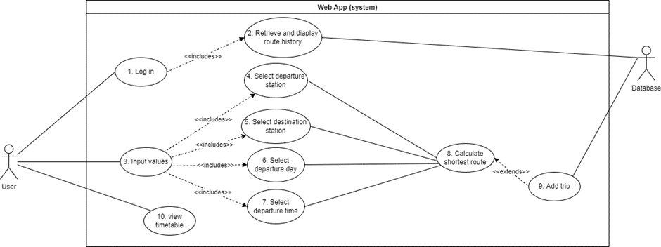Figure 1: Use Case Diagram

Typical course of events:

Actor Action | System Response
- User logs in | - Retrieve unique route history and suggest trips
- User enters departure station, destination station, day, and departure time. | - Validate stations, day, and time.  - Calculate and display shortest route.  - Add trip to database.

1. Login – A user who has signed up has unique details to login. Once they log in the system will find previous trips from the database to make suggestions on stations to travel between.

Alternate course of events
Actor Action | System Response
User does not log in. | System behaves the same, except no previous routes (suggestions) are displayed and no shortest route calculations are stored in the database.
User enters invalid login details. | System responds with error message and prompts valid login details.

3. Input values – This is when a user chooses specific stations (one for departure and one as a destination) as well as the day they would like to travel and a departure time (optional).

Alternate course of events
Actor Action | System Response
User clicks on links to train schedules. | Open pdf files of schedules in new tab.
User enters invalid departure station and/or destination station. | System gives error message and prompts for valid stations.
User enters invalid day. | System gives error message prompting for a valid day.
User enters the same station in both departure and destination fields. | System responds with message saying they are already at the required destination.
User enters no time. | System will display all routes between the given stations on the day given. These will be ordered by time, so the quickest trip will be first.

7. Calculate shortest route – The values that were input are then validated and, if all input is valid, they are passed into a function which consists of an algorithm to calculate the shortest route which coincides with the given time. This route is displayed on the web app as a list of trains (including times) the user must take to achieve the fastest trip.

Alternate course of events
Actor Action | System Response
Input values have no trains that can achieve this requirement. | System will inform the user of this unfortunate situation.

8. Add trip – The trip is then added to the database with the users ID, given they have logged in.

Alternate course of events
Actor Action | System Response
User is not logged in. | Trip is not added to database.

9. View timetable – The user can also just simply view the times that trains arrive at specific stations via links on the home page.

Design Overview
There are 4 main sections that make up the architecture of our program:
1. User Interface: This is the front end of the program that the user will see and interact with to allow them to interact with the application for its intended purpose
2. Search: This is the heart of the backend of the program that executes commands depending on the user inputs. It takes the information that is received from the user interface as well as from the database and text files. Combining all the data gathered, it generates an output to be displayed on the website.
3. Database: This is where all the information about the trains, user, and their histories are stored. It is accessed when searching for train routes, storing the user information when a user signs up, checks usernames and passwords when users signs in and retrieving users’ past search histories.
4. Text files: This is a package that provides addition information when searching for appropriate routes to take in order to compute and generate the relevant output.
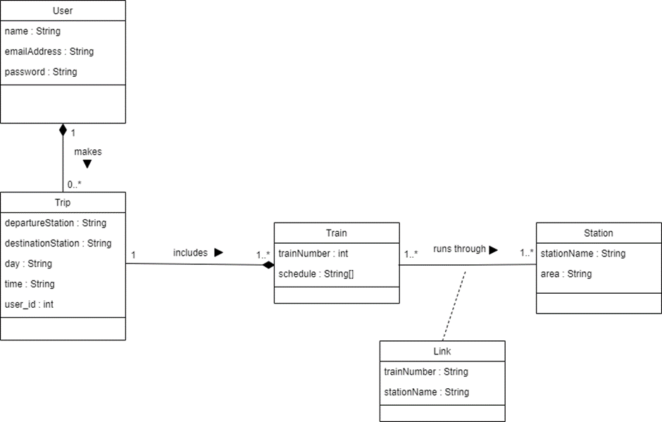Figure 2: Design Class Diagram

In Python there is no existence of private variables, so object variables could be accessed from outside the class regardless of whether there were getters or not. Henceforth we felt it not necessary to implement getters and rather just access class variables as “class name”.”variable” wherever it was needed.
The class set-up is as follows:
There are trains which run through the same handful of stations everyday of the week. However, some stations have multiple trains which pass by and so we needed a connecting class to distinguish between the trains. Each train also has a schedule which differs on days – Monday to Friday is always the same but Saturday and Sunday differ slightly.
A user is then able to make a trip which consists of a handful of trains they must take to achieve the shortest route which matches this trip.

User Interface:
HTML was chosen to design and implement the interface for the application. It was considered the best language to use to create the interface as it provides easy methods of creating the objects and separates the backend code from the frontend. It is also easy to access code from the backend to be displayed onto the web application and prevents errors from the backend disrupting the main functionality of the interface. It also is easy to write and maintain in comparison to other languages when creating an interface.

Search and Store
Search and Sort incorporate the searchRoute class and auth class. The searchRoute algorithm uses an array of functions to find the routes available for the specified departure and destination stations and the specified day and orders them according to closest time to the users’ specification and then duration. This algorithm uses a Dijkstra map to find the shortest route available and uses this route to find connecting stations between areas. The Dijkstra was determined to be the best mapping algorithm as it connects all the stations to their connecting stations and determines the shortest possible routes between the stations. It is simple to code and accurate. The auth class uses a simple algorithm to store the user information and search history into the database. The database was chosen to store this information as it provides simpler methods for storing and retrieving user data.

Database
A SQL Database was created to store the user’s personal information and search history, as well as the information of the trains in tables separated according their area, namely North, South and Central. Each area table stores the following information: Working time, Departure Location, Arrival Location, time of departure, Train number and Route. A SQL Database was implemented as it is easiest to use when searching through for information with use of SQL queries in python. The Flask-SQLAlchemy tool kit also allowed for easy mapping between object classes and tables in the database.

Textfiles
Textfiles were used to store names of stations, different routes available for each area and the duration between stations of each area. Textfiles were considered best for this data as it is simple to read into python and split by commas in order to store them in an array instead of using SQL queries.

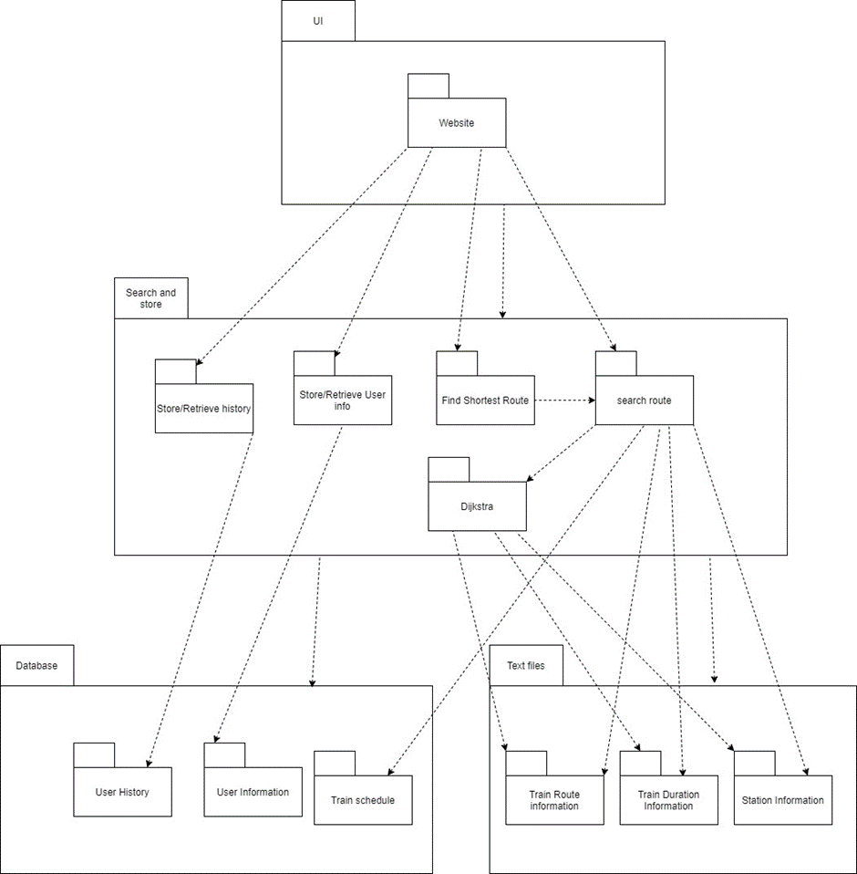Figure 3: Architecture Diagram

Implementation

User Interface
Our web user interface consisted of a base.html file which included a navigation bar for easy movement between pages for users. The following html files were then extensions of this base file:
- sign_up.html - This page was used for users who wished to add their details to the database so that their searches would be stored.
- login.html - This was for already registered users to log in and view previous trips they had made.
- home.html - This was the main page where users were able to input values and calculate a shortest route. They could also view train schedules via this page. Logged-in users were also shown previous trips.
- result.html - This was the page that displayed the results of the calculation which was a list of trains to take.

We used a python library called Flask to create our web application as it made linking the html files to the backend programs much simpler. We used another library called Flask-SQLAlchemy which is a tool kit for python and databases, which allowed us to link tables in the database to objects (classes) so that we could run queries on the database for both the algorithm and validation of any input data. Another library called Flask-login allowed us to easily manage whether a user was logged in or not and it stored the users session so they would be remembered when accessing the application again.

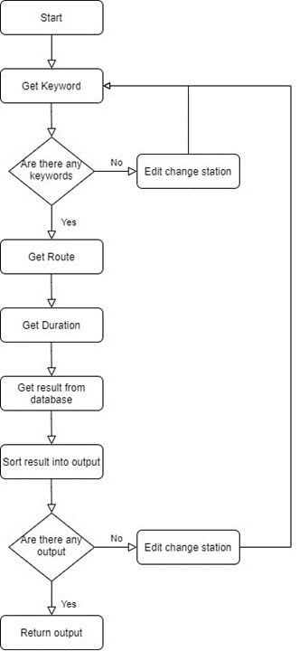Figure 4: Flow Chart of Search Route class

Search Route
The core file is called searchRoute, the website will be calling the function to find all the routes that goes from start to end. This returns a 2d array in this format: [list of routes] [route information]. Dijkstra is used for finding the shortest path between two locations. The information from Dijkstra will be passed to searchRoute. searchRoute uses this information and get a list of the routes. shortestRoute is used for finding the shortest duration and closest time to the user wanted departure time.
This is a flowchart of how the searchAllRoute () function in searchRoute works.
The searchAllRoute imports the Functions class for most of its functions. These are the mos important functions used in the searchAllRoute () function:
Get Keyword: This is the most important function in the program, this will return a list of unique keys that represents all the routes that a user can take from start to end destination. All other functions build up from this function.
Get Route + Get Duration: This is the build up from getKeyword. It will first find all the stations that the train will go past, use that information combined with their duration information will return the time it takes for the train to travel from start to end.
Get result from database and sort result into output: This is retrieving the data from the database and sort it before other programs uses it.
Output Paths + Order Paths: This receives an array of all the possible paths available, checks that they are viable and then orders them according to time closest to the start time and then by duration. It then returns an array of strings that contains the ordered routes in a readable format to be displayed to the user.
Special programming techniques: We used SQL queries to help us find the train routes from the database. SQL queries are good at searching and sorting information throughout the whole database with simple lines. We used PyPDF and its build in functions to help us easily read the pdf. I also used time library to help me improve the efficiency of the program. We can limit the runtime below 0.01 seconds which is really fast considering all the information we need to search through.

Program Validation and Verification
Our program has gone under extreme testing to ensure that it is bug and error free. To achieve this, we have implemented multiple testing techniques listed in the table below.
Table 1: Summary Testing Plan
Process | Technique
Class Testing: test methods and state behaviour of classes | Random, Partition and White-Box Tests
Integration Testing: test the interaction of sets of classes | Random Tests
Validation Testing: test whether customer requirements are satisfied | Spelling, Use-case based black box and Acceptance tests
System Testing: test the behaviour of the system as part of a larger environment | Recovery, security, and performance tests

Table 2: Summary of tests implemented
Type of test | Why | How | Result | Normal cases | Extreme cases
White Box Testing | To ensure that the input and output are correct | We have used multiple if else and print () statement in the program. We will have an expected output in our head and compare that output with the actual output. | If the result passes, then we continue, otherwise we will fix the code before continuing. | Passed | N/A
Random Testing | To ensure that the functions will work with random inputs and outputs | test all functions and compare it with its output. Use random values as our input, formulate the output ourselves and compare the result using junits. | If we fail something in junits, then we try to figure out why. If we pass it, then we continue with the remaining work | Passed | Passed
Partition Testing | To ensure that the functions will work with any kind of inputs and outputs that represent different kind of inputs. | We use values like “Kraaifontein to Brackenfell on Monday”, if this works, then all trains in that partition (Area North with only 1 train) should work. You can see out inputs in testing.py | If one testing fails, we assume that all partition related to that test fails. So we fix the problem related to that partition | Passed | Passed
Acceptance test | To see whether the user will be able to use the program to their satisfaction | We have manually checked whether the output created is correct and able to use. We see if the shortest time is the shortest if the closest time to depart is the closest time. | When we found something that we do not like about the output, we tried to change our code so that the output is acceptable | Passed | Passed
Use-case based black box: | To ensure the customers satisfactory | We have run the website on different computers to ensure that it works with them. We have asked multiple people to use the application to hear from their feedback. | The website functions just fine with different computers. From feedbacks, We improve our website for better user experience | Passed | N/A
Recovery test | To ensure that data is not lost due to break down or accidental close of the application | We do many different testings, once bug is found, we fix them immediately. We tried to store then close website immediately, check if the database was able to record the data. | The program is working better every time we fix a bug. Everything is recorded in the database, so nothing is lost when website is closed suddenly after the clicking of the button | Passed | Passed
Security test | To ensure the privacy of the users | we have created a user and password protection to ensure that all users have their own account if they want it. We tried to log in with different account using different passwords. Checking if the user can log in. | When the user enters an username with wrong password, there will be an error preventing them from accessing the other account’s data | Passed | N/A
Performance test | To improve efficiency | We import time.  User time.start() and time.time() to measure the time taken to execute different inputs | Simon’s Town – Strand on Monday took 0.006  Mowbray – Stellenbosch on Saturday took 0.005  Cape Town to Avondale on Monday took 0.0076.  The time normally won’t go over 0.01 seconds | Passed | Passed
Spelling Testing | To ensure that all spellings of the train stations are correct | We have written a python file TextOrganizer.py. This file will go through all the Train Route and compare them with the duration, If anything is missing or misspelt, it will return an error | We find the location that caused the error. Edit text files then rerun the program to check for if we have any more errors | Passed | Passed

Samples of test results

Search Route time take to complete:
- Woodstock – Claremont: 0.012 seconds
- Worcester - Simon’s Town: 0.023 seconds
- Cape Town – Strand = 0.01 seconds
- Avondale – Cape Town = 0.0076 seconds

Conclusion
The application meets all the specified requirements, providing the user with, not only one available route, but multiple that are ordered by closest start time to what was requested and then by duration to minimise travel time. The application allows the user to sign-up and login, without the user having to re-enter information if data entered was incorrect. It also stores the user’s search history and displays it. When searching for departure and destination stations, a drop-box is given to allow the user to search for a station, and if the same station is entered, an error message appears. An error message also appears if the user has not entered a time. The application also allows for the user to view a pdf of the train schedule. The application is also very efficient, with the search function performing mostly below 0.02 seconds. The application uses efficient storing structures, namely a SQL database and textfiles, that store data appropriately and in a format that is easy for the application to read and access efficiently.
Appropriate data structures, such as lists and arrays, are used to allow the storing of data to be passed on to functions in a manner that is logical and readable. This allows the application to be efficient and accurate when transferring and receiving data structures. All boundary paths, testing routes from stations within and outside of the same area were tested manually, ensuring that routes can be provided to all stations. Durations and times were also manually checked to ensure that the output created was accurate and ordered according to closest start times and durations. The application’s performance is satisfactory, meeting all the basic requirements for the application and ensuring easy usability for the client.
The application could be improved in the future to incorporate areas outside of Cape Town and using different modes of transport. It could also include an option to not insert a time or to enter a desired arrival time.

User Manual
